CITY OF FOSTORIA
In Partnership with City of Tiffin and Seneca County
COMMUNITY HOUSING IMPACT AND PRESERVATION PROGRAM
APPLICATION FOR FUNDING Program Year 2020

PLEASE DIRECT ALL COMMENTS AND QUESTIONS TO TIFFANEY SHAVER AT GREAT LAKES COMMUNITY ACTION PARTNERSHIP, TLSHAVER@GLCAP.ORG NO LATER THAN JUNE 15TH, 2020

The City of Fostoria is eligible to apply to the State of Ohio, Development Services Agency (ODSA) for Community Housing Impact and Preservation (CHIP) funding. The CHIP program is funded under the Community Development Block Grant Program (CDBG), HOME Investment Partnerships Program (HOME), and Ohio Housing Trust Funds (OHTF). CDBG and HOME funds originate with the U.S. Department of Housing & Urban Development (HUD), and OHTF originate with the State of Ohio.

The ODSA encourages and incentivizes cities and counties to partner on the CHIP application. The City may apply alone for CHIP funding of up to $300,000. City of Fostoria is eligible to partner with the City of Tiffin and Seneca County. Together, the partners may request up to $1,050,000 in funding.

City of Fostoria, City of Tiffin and Seneca County have reached an agreement to partner for the PY2020 City of Fostoria CHIP program. The City of Fostoria is to serve as lead applicant and grantee. In the PY2018 City of Fostoria CHIP program the three communities are in a similar partnership.

CHIP is a competitive grant program - not all applicants will receive funds.

Eligible Project Categories with Respective Activities
Rehabilitation Assistance
Owner Rehabilitation - City of Fostoria PY2020 Request $549,000
Rental Rehabilitation – City of Fostoria PY2020 Request - TBD
Repair Assistance
Owner Home Repair - City of Fostoria PY2020 Request $315,000
Rental Home Repair - City of Fostoria PY2020 Request - TBD
Homeownership Assistance
Homeownership (DPA/Rehabilitation) - City of Fostoria PY2020 Request - TBD
New Construction - Habitat for Humanity - City of Fostoria PY2020 Request - TBD
Tenant-Based Rental Assistance - City of Fostoria PY2020 Request $60,000
Administration - City of Fostoria PY2020 Request $123,500
Fair Housing - City of Fostoria PY2020 Request $2,500

All housing activities completed with CHIP Program grant funds must be single-family homes, as defined by the U.S. Department of Housing and Urban Development (HUD) as one to four units.

REHABILITATION ASSISTANCE

Owner Rehabilitation
Funding Source(s): CDBG & HOME
Eligible Activity Regulation: 24 CFR Part 570.202 or Part 92.205
OCD Maximum Per Unit Limit of Assistance: $64,000 (including soft costs)

The purpose of the Owner Rehabilitation activity is to improve and protect the supply of sound, serviceable, and affordable owner-occupied housing stock. Through this activity, financial assistance is provided to homeowners with income levels at or below 80 percent of Area Median Income (AMI) to correct substandard conditions so that the homes are safe, healthy, durable, energy efficient and affordable. Owner Rehabilitation is intended to address problems throughout the house. Because rehabilitation must correct all substandard conditions that adversely affect the occupant’s health and safety and the dwelling’s structural integrity, the scope of work is generally comprehensive, and the cost is usually high. However, cost limitations often require the work to be prioritized so that the most substandard conditions (i.e., problems effecting occupant health and safety and structural integrity) are corrected before less important concerns are addressed. Ohio Development Services Agency (ODSA), Office of Community Development (OCD) expects that all of the substandard conditions be corrected before a project is considered complete. Homes that have numerous problems that cannot be corrected within the limit of financial assistance are inappropriate projects and must not be rehabilitated. The rehabilitation standard to which all projects must comply is located in Part II of the OCD Housing Handbook known as the State of Ohio Residential Rehabilitation Standard (RRS).

Rental Rehabilitation
Funding Source(s): CDBG, HOME, & OHTF*
Eligible Activity Regulation: 24 CFR Part 570.202 or Part 92.205
OCD Maximum Per Unit Limit of Assistance: $64,000 (including required landlord contribution and soft costs)

The purpose of the Rental Rehabilitation activity is to improve and protect the affordable renter-occupied housing stock. Through this activity, financial assistance is provided to property owners to correct numerous substandard conditions so that the rental units are safe, healthy, durable, energy efficient and affordable. Rental Rehabilitation construction standards are the same as owner rehabilitation above.
Only units occupied by tenant households with income levels at or below 80 percent of AMI may receive rental rehabilitation assistance. For a duplex or a building with 3 to 4 units, only units occupied by tenant households with income levels at or below 80 percent of AMI and common areas may receive rental rehabilitation assistance. Generally, common areas are the structural components or mechanical systems that are shared by all of the tenants (such as a common hallway, roof or single HVAC system).
Rental units that are in poor overall condition and/or that have serious problems that cannot be corrected within the limit of financial assistance are inappropriate projects and must not be rehabilitated unless sufficient funds from supplemental sources exist.
The rental units can be owned by private investors or by non-profit organizations. To ensure that the tenant households with income levels at or below 80 percent of AMI are the primary beneficiaries of the rental rehabilitation activity, two important requirements must be followed. First, for-profit property owners must contribute 50 percent of the project hard costs to the project. OCD expects grantees to receive the contribution prior to issuing a ‘Notice to Proceed’. Second, to help ensure that the property remains in the affordable rental housing stock inventory, the property owner must agree to rent the unit to tenant households, with income levels at or below 80 percent of AMI, for the 10 year affordability period. Also, the owner must agree to limit the rent so that it cannot exceed the appropriate Fair Market Rent (FMR) for the same period of affordability. The unit’s affordability must be enforced through a recorded loan document.

REPAIR ASSISTANCE
Capped at 30% of the total grant request

Owner Home Repair
Funding Sources: CDBG and OHTF*
Eligible Activity Regulation: 24 CFR Part 570.202 (b, 2, 4, 6, 7 (iv), and 11)
OCD Maximum Per Unit Limit of Assistance: $18,000 (including soft costs)

The purpose of the Owner Home Repair activity is to help preserve the affordable housing stock by providing owner-occupied households with income levels at or below 80 percent of AMI with limited financial assistance to correct significant problems in the home. Unlike owner rehabilitation, which addresses the entire home, the owner home repair activity can address one or more (if connected / related) specific problems that adversely affect occupant health and safety and/or structural integrity.
The types of work that are generally considered eligible for the Owner Home Repair activity include: structural system repairs, mechanical system repairs, plumbing system tap-ins, wells and septic systems, weatherization, accessibility, and LBP hazard reduction.

Rental Home Repair
Funding Source: CDBG and OHTF*
Eligible Activity Regulation: 24 CFR Part 570.202 (a,1);(b, 2, 4, 6, 11) (e)
OCD Limit of Assistance: $18,000 per housing unit (including required landlord contribution and soft costs)

The purpose of the Rental Home Repair activity is to improve and protect the affordable renter-occupied housing stock. Through this activity, financial assistance to the property owners is limited to correcting one or more (if connected / related) specific problems that adversely affect occupant health and safety and/or the unit’s structural integrity. The rental units can be owned by private investors or by non-profit organizations. To ensure that the tenant households with income levels at or below 80 percent of AMI are the primary beneficiaries of the rental home repair activity, two important requirements must be followed. First, for-profit property owners must contribute 50 percent of the hard costs to the project. OCD expects grantees to receive the contribution prior to issuing a ‘Notice to Proceed’. Second, to help ensure that the property remains in the low-income rental housing stock inventory, the property owner must agree to rent the unit to tenant households with income levels at or below 80 percent of AMI for a period of two years. Also, the owner must agree to limit the rent so that it cannot exceed the appropriate FMR for the loan’s required two-year period. The unit’s affordability must be enforced through a recorded loan document. Rental home repair assistance shall be provided to the property owner in the form of a 0 percent interest, 100 percent deferred/declining (50 percent annually), forgivable loan, with a term of two years. The standard to which the rental home repair work must comply to the same regulations as owner home repair listed above.

HOMEOWNERSHIP ASSISTANCE

Homeownership- Down Payment Assistance/Rehabilitation
Funding Source(s): HOME
Eligible Activity Regulation: 24 CFR Part 570.201 (n) and Part 92.205
OCD Maximum Per Unit Limit: $65,000 (including soft costs)

The Homeownership activity is, in effect, a combination of down payment assistance and the owner rehabilitation activity. Accordingly, the purpose of the homeownership activity is to increase the number of owner-occupied households with income levels at or below 80 percent of AMI, and to improve and protect that housing stock.
Through this activity, financial assistance is provided to households to purchase homes. The assistance may include providing a subsidy to lower the interest rate for the loan and/or principal amount, providing down payments, and paying reasonable closing costs. All loans from financial institutions must, at a minimum, meet the requirements outlined in OCD’s underwriting process.
The standard to which the acquired homes must comply is the State of Ohio RRS, and any locally-adopted codes. For homes that do not meet this standard at the time of purchase, the homeownership activity also provides financial assistance to correct problems with those homes. To ensure that homes are safe, all defects that adversely affect the occupants’ health and safety must be corrected immediately following the purchase closing, but prior to the buyer occupying the home. To ensure that the home meets the RRS within a reasonable timeframe, all rehabilitation work must be completed within six months of the purchase closing.
In addition, the Homeownership activity must also include homebuyer counseling to help ensure that participants are well informed about private financing and the real estate purchasing process. The required homebuyer counseling budget must not exceed $500 per household and the counseling content must comply with the current HOME Final Rule. Prior to the purchase, the homebuyer education program must cover the following areas:
- homebuyer decision process,
- budget and credit management,
- mortgage loans and closings,
- fair housing issues and
- home maintenance and repair practices.
Successful homeownership activity implementation requires strong working relationships with each party involved in the process. Clients must clearly understand the program and their obligations, such as attending education sessions, obtaining financing, selecting a home and financially contributing to the transaction. A major success factor is long-term affordability. Not only must the monthly mortgage payments be affordable, but the other housing costs such as taxes and insurance must also be affordable. OCD defines affordable as payments for principal, interest, taxes and insurance (PITI) that do not exceed 30 percent of gross monthly household income.

New Construction-Habitat for Humanity
Funding Source(s): HOME
Eligible Activity Regulation: Part 24 CFR 92.205
OCD Maximum Per Unit Limit of Assistance: $30,000 per unit (including soft costs not exceeding 10 percent of CHIP hard costs)

The purpose of the New Construction-Habitat for Humanity (Habitat) activity is to create new permanent housing to expand the affordable owner-occupied housing stock. Generally, successful implementation of this activity requires extensive planning and coordination with the Habitat affiliate. A subsidy is provided to the Habitat affiliate for a new home construction to be purchased by a partner family with a household income that does not exceed 80 percent of AMI. When providing a subsidy to Habitat projects (whether as a development subsidy to the project, or as an affordability subsidy to the buyer), all grantees shall abide by the resale affordability provisions as outlined in 24 CFR 92.254. Principal, interest, taxes and insurance, after program assistance, shall not exceed 30 percent of the household’s total monthly gross income, as calculated for determining income eligibility. Grantees shall provide homebuyer counseling with a cost not to exceed $500 per household and the counseling content must comply with the current HOME Final Rule.
Homes constructed under this activity must comply with all applicable building/construction codes. If no local codes exist, the unit must comply with the RRS.

TENANT-BASED RENTAL ASSISTANCE

Funding Source(s): HOME
Eligible Activity Regulation: 24 CFR Part 92.205 and 92.209
OCD Limit of Assistance: payment based on housing payment and household income

The purpose of the Tenant-Based Rental Assistance (TBRA) activity is to provide affordable monthly rental payments for tenant households with income levels at or below 60 percent of AMI. To ensure that the rental units are decent, safe and sanitary, TBRA-subsidized units must meet the U.S. Department of Housing and Urban Development’s Housing Quality Standards (HQS). Through this activity, grantees provide limited financial assistance to property owners to subsidize their income-eligible tenant’s monthly rental payments. Generally, the subsidy payment is an amount equal to the difference between the established rent standard (based on local market conditions or the FMR for the unit size) and 30 percent of the tenant household’s adjusted monthly income. Payments can also include security and utility deposits. Utility deposits can be provided only in conjunction with rental subsidy and/or security deposit assistance. Grantees generally contract with their local housing authority to implement TBRA Programs, although it is not required. TBRA programs are generally modeled on the HUD Section 8 Voucher Program. The Voucher design places a cap on the subsidy, but does not limit the rental amount that property owners can charge. Tenants must pay the difference between the rent and the subsidy. Clients may choose units that rent for more than the rent standard or FMR; however they must pay the difference even if that amount is more than 30 percent of their adjusted monthly income. Families or individuals provided with TBRA must be selected on the basis of one of the following:
- The Section 8 waiting list of a Public Housing Authority (PHA) operating within the jurisdiction of the CHIP grantee based on preferences established by the PHA.
- A waiting list established by the participating jurisdiction based on the established federal preferences and/or local preferences.
- Eligible families that currently reside in units that are designated for rehabilitation under the HOME program without requiring them to be placed on the PHA waiting list.

Section 504 of the Rehabilitation Act of 1973 prohibits the provision of federal financial assistance for disability-specific housing [see 24 C.F.R. Section 8.4(a)]. Therefore, housing projects funded with HOME or CDBG funds may not restrict occupancy to people with specific disabilities. Jurisdictions may, however, request OHTF funding for projects that provide rehabilitation and repair assistance to units designated for disability-specific clientele.

*Projects funded with OHTF dollars must benefit clientele at or below 50 percent of AMI.

Proposed City of Fostoria PY20 CHIP

The project would run for the period of September 1, 2020 – February 28, 2023. The total funding to be requested is $1,050,000. This is based on a City of Fostoria maximum request of $300,000, a City of Tiffin maximum request of $350,000 and a Seneca County maximum of $400,000. Services are designed for Fostoria, Tiffin and County households with incomes less than 80% of median, with some activities restricted to lower maximum incomes.

A comprehensive overview of City of Fostoria’s service area (Seneca County) was conducted to determine the housing needs of the County. This was achieved by completing a broad view of all community service needs by communicating with local and regional service providers. This process provided greater understanding of the services available to the citizens and any gaps in services.

Based on the results of this survey the City of Fostoria in partnership with the City of Tiffin and Seneca County purpose to include the following activities and their funding levels (note: all primary activities include estimated project soft costs necessary to implement and complete the activities):

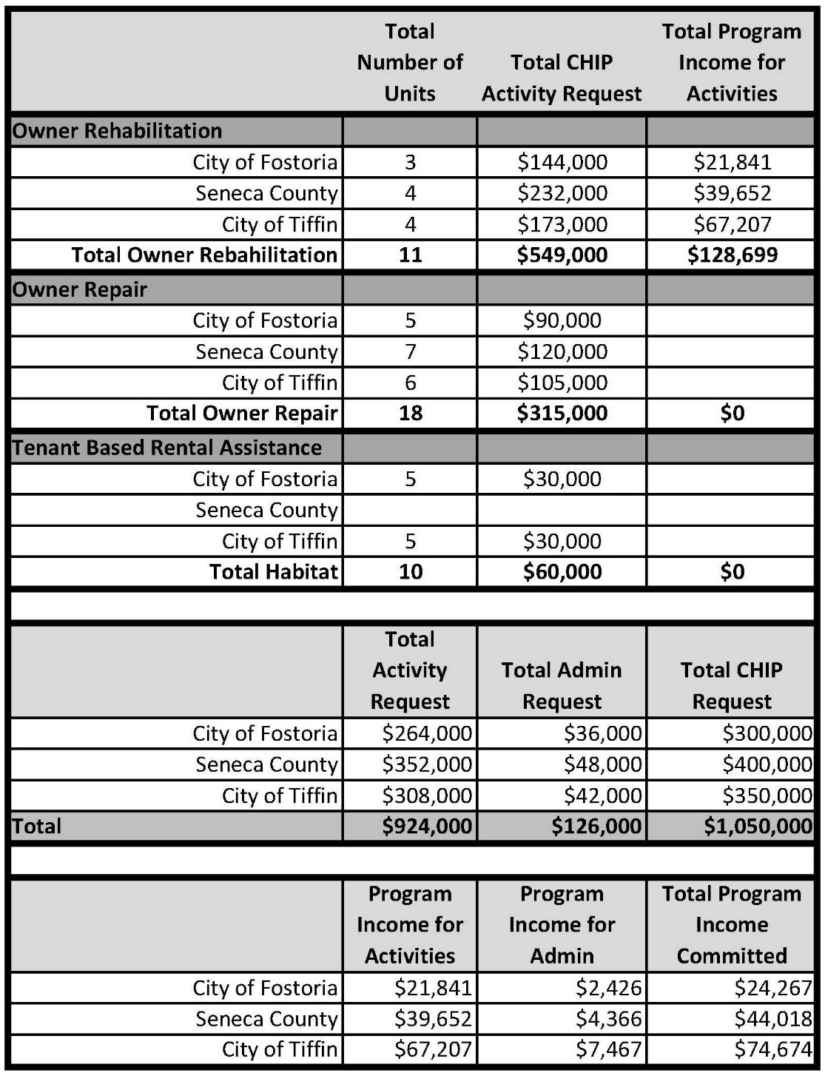

City of Fostoria’s funding request will be from the following funding sources: HOME funds: $555,165; CDBG funds: $389,835; OHTF Funds: $105,000. The partners are also committing program income funds for related activities.

Application Timing: Submission: June 24, 2020 // Grant Award: September 1, 2020

PLEASE DIRECT ALL COMMENTS AND QUESTIONS TO TIFFANEY SHAVER AT GREAT LAKES COMMUNITY ACTION PARTNERSHIP, TLSHAVER@GLCAP.ORG NO LATER THAN JUNE 15TH, 2020

