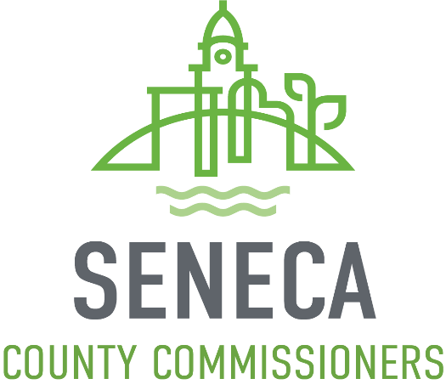

SENECA COUNTY FAÇADE ENHANCEMENT PROGRAM GUIDELINES

PROGRAM OVERVIEW
The Seneca County Commissioners are providing a grant program for the purpose of revitalizing exterior facades in Seneca County. The Seneca County Façade Enhancement program was designed for the purpose of providing grant funds to assist with revitalization of exterior facades across Seneca County, areas not currently part of other façade enhancement programs. This program was created for commercial buildings and excludes single family dwellings or multi-family dwellings, commercial farm operations, chain retail as well as national franchises. Property owners may re-apply to the program annually for available funds, but priority will be given to first-time applicants. Fifty percent of all allocated funds will be designated for Tiffin and Fostoria with the remaining fifty percent allocated for villages and rural businesses of Seneca County.

GRANT
The Seneca County Façade Enhancement Grant is up to a 50% reimbursement of expenses directly related to qualifying building improvements to commercial properties within the Seneca County, except those within another façade enhancement program area, up to a maximum match of $5,000.
This grant program is on a first come, first serve basis from application to approval.
• Applications will be reviewed in the order they are received.
• Incomplete applications will not be accepted.
• Applications should be submitted prior to any work is begun.
• It is the property owner’s responsibility to ensure all proper permitting is secured and all work meets state, county and local zoning and building codes.

Eligible Improvements
Eligible improvements include all exterior improvements to the appearance of an eligible building front façade. These improvements include:
• Awnings
• Masonry work: brick cleaning, tuck pointing, replacement
• Painting
• Repair, restoration or appropriate replacement of exterior windows and doors
• Repair or replacement of roofing system (including gutters and downspouts)
• Fire escapes or exterior upper floor access
• Any other visible exterior improvements
The general purpose of this program is to improve the appearances of properties that are visible from the street. The program does not intend to provide funds to assist with the sides or rears of properties. However, there are several buildings at street corners in the program area and those cases may be considered to have two fronts and would be eligible to receive funding for qualifying improvements on any part of the building which is immediately adjacent to a street. This does not include alleys.
If there is a building where there is no entry facing a main road, the side of the building with the most prominent entry will be considered the "front" facade of the building and eligible for facade grant funds. This will not include the back of a building with a rear entry.
A property that functions as one building, regardless of the number of tax parcel numbers assigned to the property or multiple and different owners, is eligible for only one grant per year.
The front facade of the building will include any façade return where the identical ornamental architectural details of the front facade, returns continuously on the side of the building. This includes, but is not limited to, the upper cornice, facade brick, facing material, stone, ornamental window trim, first floor cornice, and storefront display windows.
Ineligible Improvements
This program will not fund interior improvements, operating funds, HVAC repair, plumbing repair, furnishing or equipment, landscaping and any exterior improvements that do not follow the guidelines, codes and/or requirements set by the State of Ohio, Seneca County, or local governing authority including design standards.

APPLICATION
All grant applications must be submitted to Seneca County Commissioners office and include:
• Seneca County Façade Enhancement Application
• Project Description
• Current photos of proposed work area. Then photos of work are after completion of project.
• Preliminary Cost estimates of proposed work by two(2) qualified third parties.
• Completed W9 Form
• Rendering/Drawing of proposed work, including color scheme (if applicable)

APPLICATION REVIEW PROCESS
A review of application to ensure all information is included, and project is eligible will be conducted. Most applications will be processed within 30 days from the date the application is received.

CONDITIONS
• The property owner will be responsible for maintaining the improvements provided by this grant for a period of 5 years.
• The property owner must obtain all required permits and plan approvals prior to beginning work. (The permits may include, but are not limited to, building, zoning, occupancy, etc.)

AWARDS
• All applicants will receive written notification as to the approval or denial of the grant award.
• Approval must be confirmed prior to commencing work to be eligible to receive enhancement funds.

CHANGE OR PROJECT
If at any time, the project changes during the work, the owner must contact SCRP to complete a change form. The changes must be approved by the County Façade Enhancement Board and meet the program guidelines.

COMPLETING THE PROJECT
•The owner has 6 months to complete the project once funding is allocated.
• Applicants must provide copies of invoices marked paid or cancelled checks showing payment.
• Applicants must provide photographs of completed work.

SENECA COUNTY FAÇADE ENHANCEMENT PROGRAM APPLICATION

Completed application must be submitted to:
Seneca County Commissioners Office
111 Madison St.
Tiffin, Ohio 44883
asauber@senecacountyohio.gov

Applicant Business: __________________________________________________________

Contact Person: _____________________________________________________________

Address: ___________________________________________________________________

Phone Number: _____________________________________________________________

Email Address: ______________________________________________________________

Total Amount of Grant Funding Requested: $ _____________________________________

Total Amount of Private Investment in the Improvements: $ _________________________

Describe how the building improvements will be a benefit to you and/or your business:

Any Additional Information:

SENECA COUNTY FAÇADE ENHANCEMENT PROGRAM APPLICATION

Project Description
Please describe the building enhancements planned for this project. Include a detailed description of work to be completed, photos of the existing conditions, a rendering of proposed work, a detailed cost estimate from a qualified third party and a complete W9 Form.

