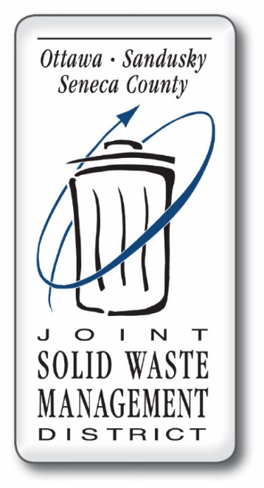
Competitive Funding Grant

If you are filling this form on your computer, click on the gray boxes and fill out information.
Do not hit return, just click on next gray box.

Organization Name:

Contact Person:

Address:

Phone:

Fax:

Email:

Please select one of the following. Computer users, click inside gray box.
Local Government Non-Profit Organization *Non-Profit Educational Institution

*Proof of Non-Profit Status Included

PLEASE NOTE:
This page and the next page are your budgetary pages. They are titled Product Information Section (PI) and Line Item Page (LI). Both of these pages must be kept in their original format, must be filled out completely and should equal each other. On the PI page you must list the product information, quantity and cost per unit. You must also justify any labor hours in your match in this section, including the hourly rate (not to exceed $10 per hour). The LI page is where you state what line item you are requesting, along with the breakdown of grant vs. match dollars. You must justify your total project completely on both of these pages.
PRODUCT INFORMATION SECTION
Please provide a budget description of all the materials that you are asking for on the Budget page. Remember to attach an original price quote from the company which includes any shipping charges. Also include proof that the material is made from at least 25 percent recycled content.
Please enter amounts in whole dollars only
Product Name | Quantity | Cost per Unit | Total Cost
Total Project Cost
Additional Comments:

Please enter amounts in whole dollars only (round up to nearest dollar amount). Please add across and down to check accuracy of your totals.
Budget Category | Grant Funds | Match Funds | TOTAL
Labor ^{1 (see below)}
Advertising
Brochures / Flyers
Recycled Signs
Recycled Benches
Recycled Picnic Tables
Playground Equipment
Recycled Plastic Cribbing
Recycled Trash Containers
Recycled Playground Surfacing
Recycled Lumber
Other Recycled Products
Recycling Containers ^{2 (see below)}
Transportation and Shipping
Other Budget Items
Other - Yard Waste Infrastructure ^{3 (see below)}
Other -
Other -
TOTAL ACTIVITY BUDGET
Max. Grant Amount $10,000
Minimum 25% match
- Labor is only eligible under the Match portion of the grant as an in kind contribution. The
District will only allow salary contributions up to a maximum of $10.00 per hour. Labor is
allowed for site preparation and assembly of recycled equipment.
- Recycling Containers would include any containers that would be used to establish a recycling program within your organization.
- If the organization is applying for funds to improve, expand or set up yard waste services, the applicant should make every attempt to purchase products made from recycled content, but this is not a requirement.

CERTIFICATION
Applicant hereby acknowledges and certifies that submitting this Competitive Funding Application Form constitutes an offer to the District to perform the programs, purchases or products described therein, and shall constitute a binding contract if and when the District approves the application and awards grant funds to the Applicant. Applicant agrees and certifies that all grant funds awarded shall be expended only for programs, products or projects having a non-sectarian purpose. All grant funds shall be expended in strict compliance with the Applicant’s Competitive Funding Application Form, as approved by the District, and the provisions of the District’s Competitive Funding Program Application Packet. Any grant funds expended in violation of such requirements shall be refunded to the District. The undersigned represents that he or she is authorized to execute this certification on behalf of the Applicant.

Signature

Print Name

Please use this worksheet as a tool to double-check your grant application. You are required to include this checklist as a part of your grant application. Checking off each item below is your declaration that this information is properly included within your application.

Applicant (person responsible for writing the grant application) attended required

meeting for funding round. Name:

Resolution by governing Board or Council is attached.

If applicant is a non-profit organization, appropriate proof of tax exempt status is attached.

Applicant has an operating recycling program in place OR Applicant is requesting funds to start or expand a recycling program.

If the organization is applying for funds to improve, expand or set up yard waste services, applicant should make every attempt to purchase products made from recycled content, but this is not a requirement.

An original price quote, including percentage of recycled content and basic documentation / product literature (i.e. picture of the product) must be attached from the vendor. (Original price quote requires that applicant must have direct contact with vendor to show that price quotes depict recent contact with vendor to prove current price and related shipping costs.)

Check here to confirm your budge page matches your price quote from your vendor.

Check here to confirm your percentage of recycled material is verified on your quote.

The application cover page form and both budget page forms are utilized as they are presented in the packet. Narrative questions may be reproduced to accommodate any space requirements applicant may have when answering questions. Both budget pages are complete and equal to one another.

Total GRANT request does not exceed $10,000. Total MATCH amount is a minimum of 25% of the TOTAL PROJECT COST. A detailed explanation of the match is included on the appropriate budget page.

Spelling and mathematical calculations are accurate.

Applicant states the number of residents, or population of persons that will benefit from this grant if awarded (i.e. school enrollment, township population, etc.).

Each applicant must submit the ORIGINAL application to the District office by 4:30 p.m. January 31st and June 30th. NO POSTMARKS ACCEPTED, NO EXCEPTIONS!

Please answer the following questions. If you prefer, you can recreate this sheet on your computer by reprinting the questions. Click by the yellow highlighted cursor below each question. This narrative will scroll down as you type.
- Please describe your organization and how it’s funded. How many people will benefit from this grant award (number of students, population, etc.)?

- Please describe the project, activity or materials you are applying for along with your project goals and objectives. Include why your organization is asking for the funding (developing a new recycling program, purchasing recyclable products, etc.). If you are buying recycled material please describe materials and attach a price quote with
documentation that the product contains a minimum of 25% recycled content.

% of recycled
Identify the type of recycled material in the box above (i.e. – aluminum, plastic, rubber, steel, vinyl, etc.)

- Please give an estimated project timeline for completion of the project and who will be
administering the project.

- If you are requesting funding to start or expand a recycling program, please describe who will be collecting recyclables and where the material will be taken.

- The District funds grants to educate the public about recycling. How will you publicize the grant award after you have completed the project? What tools will you use to convey this message (signs, media, newsletters, etc.)?

- The District requires that the organization have a recycling program in place. Please describe the current recycling program in your organization.

- The District makes every effort to keep grant funding local. Priority may be given to
applicants using an in-district vendor or in-state vendor.

*Name of Vendor

*Address of Vendor

If a local vendor is not attainable, please explain.

