FOR IMMEDIATE RELEASE Contacts:
Bryce Riggs
Interim President & CEO
Tiffin-Seneca Economic Partnership
Briggs@senecaregionalchamber.com

Renee Smith
President
Fostoria Economic Development Corporation
President@fostoriaedc.org

Tiffin-Seneca County Micropolitan Ranked #6 in the Nation for Economic Development
Region Maintains Strong National Presence in Site Selection’s 2024 Micropolitan Report

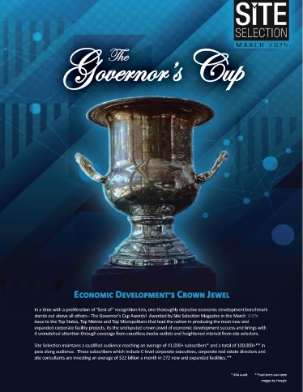
TIFFIN & FOSTORIA, OHIO — March 3, 2025 - The Tiffin-Seneca Economic Partnership and the Fostoria Economic Development Corporation are proud to announce that the Tiffin-Seneca County Micropolitan Area has been ranked #6 in the nation in Site Selection Magazine’s annual rankings of economic development projects.

This ranking places the region among the top-performing micropolitan areas nationwide, competing against 543 similar-sized communities with populations between 10,000 and 50,000. This marks the 13th consecutive year that the region has ranked in the top 10% nationally, further solidifying its reputation as a leading destination for business growth and investment.

This achievement underscores Seneca County's unwavering commitment to economic growth and development. In 2024, the community saw a number of transformative projects that contributed to this national ranking.

Tiffin saw continued growth with expansions and investments from American Plastics, National Machinery,
and Webster Industries. Fostoria had significant projects with Frankart Electric, Kuzma Industries, Mennel Milling, National Spinning Co., POET Biorefining - Fostoria, and Premier Industrial Machine, as well as the attraction of Carolina Nonwovens to Ohio and Fostoria. Additional countywide investments included projects from Church & Dwight and Schreiner Manufacturing.

These projects reflect the diverse industries driving economic momentum in Seneca County, including manufacturing, construction, energy, and industrial machinery. The collaboration between the Tiffin-Seneca Economic Development Corporation and the Fostoria Economic Development Corporation has played a pivotal role in securing the region’s standing among the top communities for economic development.

Seneca County Commissioner Tony Paradiso praised the county’s consistency in economic development:
"Ranking in the Top 10 nationally for 13 consecutive years is no small feat—it’s a testament to the dedication of our business community, economic development teams, and local leadership. We continue to see strong investment in Tiffin, Fostoria, and throughout Seneca County, and we are committed to sustaining this momentum."

Tiffin Mayor Lee Wilkinson emphasized the city’s growth and strategic partnerships:
"Tiffin’s economy remains strong because of the commitment of our businesses. This national recognition reaffirms that we are a premier destination for investment, and I look forward to building on this success."

Fostoria Mayor Don Mennel highlighted regional collaboration as a key factor in the ranking:
"Fostoria continues to be a leader in economic development, and our partnerships play a crucial role in securing these rankings. The investments made in Fostoria’s industrial sector are creating jobs and opportunities, and I am proud to see our efforts recognized nationally."

With this sixth-place national ranking, the Tiffin-Seneca Economic Partnership and the Fostoria Economic Development Corporation remain dedicated to advancing economic opportunities, fostering business innovation, and strengthening the regional economy for years to come.

About the Tiffin-Seneca Economic Partnership
Started in 1983 as the Seneca Industrial and Economic Development Corp. (SIEDC), the Tiffin-Seneca Economic Partnership is a private, non-profit corporation dedicated to driving positive economic, downtown, and community development in Tiffin and Seneca County, Ohio, which consistently ranks among the top communities nationally for economic development. Learn more about the great things going on in Tiffin and Seneca County at www.tiffinseneca.com.

About the Fostoria Economic Development Corporation
Established in 1956 as the Fostoria Community Industrial Association, the Fostoria Economic Development Corporation (FEDC) is a private, non-profit corporation dedicated to driving positive economic, downtown, and community development in Fostoria and surrounding area in Hancock, Wood, and Seneca Counties, which consistently rank among the top counties nationally for economic development. Learn more about the great things going on in Fostoria at www.fostoriaedc.org.

